**Development Rates**

**Development rates for 1 month**

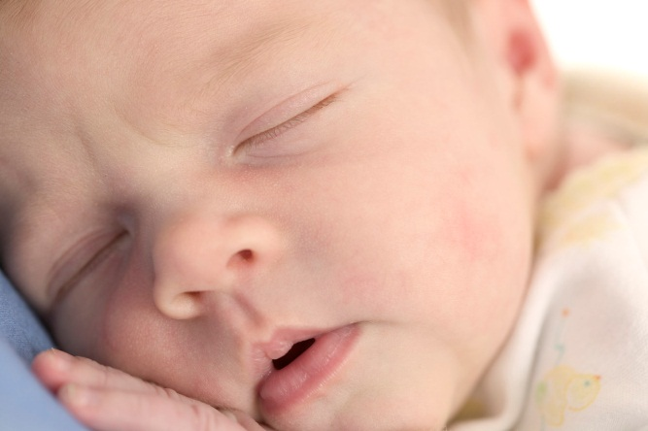

**Communication and Intellectual Development.**

Communicates via physical closeness

Expresses needs using crying

Expresses needs using noise

Will start to gurgle and coo in response to carers

**Physical Development.**

Gazes at faces intently mostly while being fed or talked to

Hands are closed tightly

Head is on one side can be lifted (In prone)

Head on side (In supine)

Survives using reflexes

When sitting head falls forwards and back curves

Will turn head towards sound or light

**Social Emotional & Behavioural Development**

Completely dependent on others

Explores using their senses

Starts responding to sounds by making own sounds

Starts to smile at about 5 weeks

**Development rates for 3 months**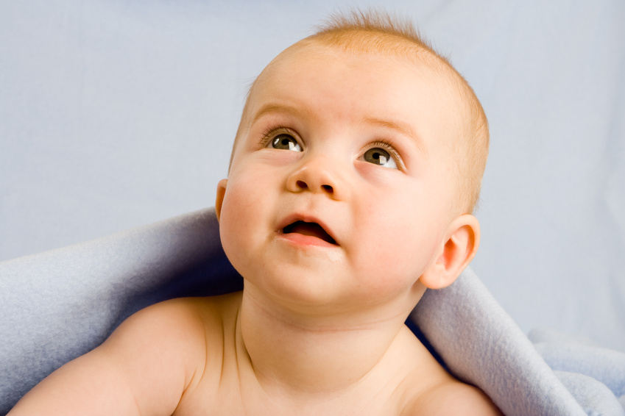

**Communication & intellectual development**

Can imitate high and low sounds

Has learned to link carers face with voice

Will make sounds in response to carer as if to make conversation, will wait for a response.

Will respond to familiar sounds

**Physical Development**

Back is straighter when sitting lets head lag

Can briefly hold a rattle

In prone head and chest can be lifted from floor when supported by forearms

In supine Head in central position

Kick legs together and separately

More alert, moves head to look around

Plays with hands and fingers

Turns side to side

Waves arms and brings them together

**Social, Emotional & intellectual Development**

Baby starts to understand they are a separate person using their senses

Can show feelings such as fear or excitement

Has a positive reaction to carer when shown affection, can also stop responding if not interacted with positively

Starts to have a sense of self and realise what they can do

Will cry if carer leaves the room

**Development rates for 6 months.**

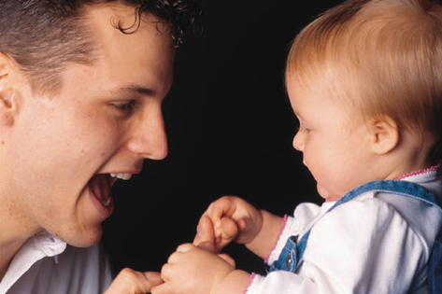**Communication and intellectual development**

Can understand ‘No’ uses and initiates a wider range of sounds

Enjoys playing with carer and holding conversations

Makes longer strings of baby sounds

Uses volume intentionally

**Physical Development**

Can bear weight when standing

Can pass objects from hand to hand

Can turn form front to back and vice versa

In prone can support head and chest with arms with hands flat on the floor

In supine in seating position head can be lifted and controlled

Is interested in bright shining objects

Palmar grip is used to pick things up and will put to mouth and explore them

Plays with feet using hands and will put them in mouth

Watches things with interest

**Development Rates 9 Months**

**Communication and intellectual development**

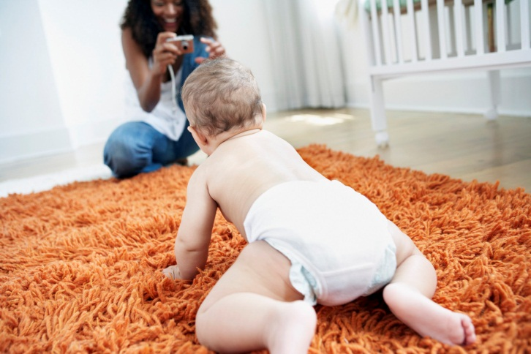Tuneful strings of babbling

Learn what key words mean, such as ‘drink’

Start to cry when left with a stranger

**Physical Development**

Using fingers to feed

Crawling or finding other ways of being mobile

Sit unaided

Become more skilled at touching things

**Social, Emotional & Behaviour Development**

Try to stay near to parent or carer

Understand that objects and people do not disappear when they are out of sight

**Development Rates 12 Months**

**Communication and intellectual Development**

Now understands that particular words relate to certain people and can use basic words in context

Understands more basic messages delivered by carers or siblings

Uses more babbling sounds and this can lead to first words

Will respond to basic instructions

**Physical Development**

Can feed self-finger foods or with a spoon

Can hold things with pincer grip and release intentionally

Can sit down from standing position

Can stand alone briefly

Clasps hands together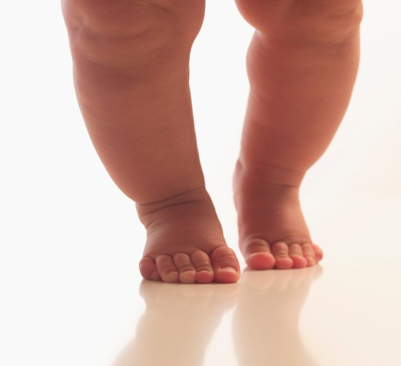

Might take a few steps

Throws toys intentionally

**Social, Emotional & Behaviour Development**

Happy to play alone or with other children for longer lengths of time

Self-esteem and self-confidence develop and has an increased sense of self

Waves goodbye when prompted, then by self

**Development Rates at 18 Months**

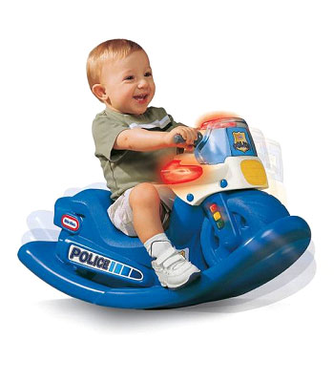

**Communication and intellectual Development**

Enjoys songs and rhyme along with actions

Explores their volume and rhythm

frequently babbling

will call for attention from main carer using sounds

**Physical Development**

Sitting and pushing off with legs on sit-and-ride toys

walks with side to side movement

Often fascinated by other children including siblings

Squats to pick up a toy

Builds a tower with 2-3 bricks

**Social, Emotional & Behaviour Development**

Knows where objects are kept

Interest in other children

Likely to become frustrated with occasional temper tantrums

**Development Rates at 2 – 3 Years**

**Communication and Intellectual Development**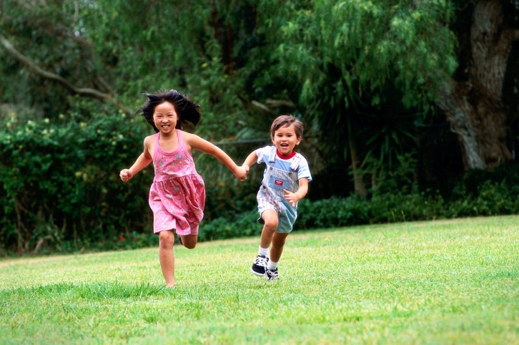

A vocabulary of around 200 words

Talks to self often

Forms sentences putting two or more words together

Provides comfort when younger siblings or other babies cry

**Physical Development**

Running and climbing

Pedalling a tricycle or pushing it along with feet

Kick a large ball gently

Walk up and down stairs usually putting two feet on each step

**Social, Emotional and Behavioural Development**

Playing alongside other children and copying their actions

Anger and frustration if they cannot do what they want to do

Likes to help others

Pretend play becomes popular

**Development Rates at 3 – 5 Years**

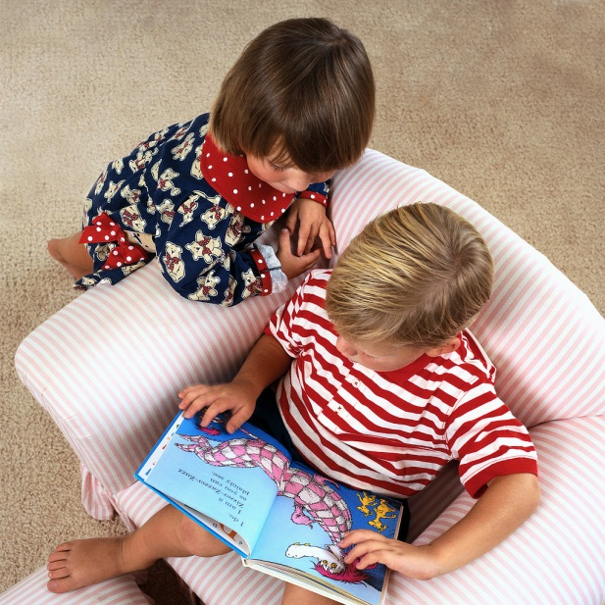

**Communication and Intellectual Development**

Speech is easily understood

Asking questions and enjoys talking

Give own name

Counts up to ten or more by repetition

**Physical Development**

Walking upstairs on alternate feet

Washes and dries hands with assistance

Can turn pages in a book one by one

Can put on and take off coat

**Social, Emotional and Behavioural Development**

Interest in other children and some cooperative play

Happier being separated from their parents as they know they will return

Respond well to adult praise and recognition

Takes joy when assisting adults in tidying up

It’s important to this is only a guide and all children develop at different rates and children who have an additional need may develop very differently.